Computer Architecture Course: IT089IU
International University – VNU HCM Date: March 2019
Dr. Le Hai Duong Time: 6 hours

Laboratory Session 4
Procedure

Part I: Procedure
- Exercise 1: Int2Hex Converter.
Write a program that
  - Read in ONE unsigned integer in the range 0 to 15. Print out that number in hexadecimal. For example, given the input 13, print out 0xD. (lab4_1_1.s)
  - Modify the previous assembly, create a procedure printHex(int num). This procedure takes in a number and print it out in hexadecimal. (lab4_1_2.s)
  - Modify the previous assembly so that it can print out hexadecimal of any 32-bit integer input. For example, read in number 546263, print out 0x855D7. (lab4_1_3.s)

- Exercise 2: Fibonacci number
The Fibonacci series is defined as:
1, 1, 2, 3, 5, 8, 13, 21, 34, 55, ...
Each term in the series is the sum of the preceeding two terms. So, for example, the term 13 is the sum of the terms 5 and 8.

2.1 Write the program as a counting loop that terminates when the first 100 terms of the series have been computed. Use a register for the current term and a register for the previous term. Each execution of the loop computes a new current term and then copies the old current term to the previous term register. Print out the series. (Use no function) (lab4_2_1.s)

2.2 Rewrite the program using function
void fibonacci(int numOfTerms); // this is C prototype

This function print out the Fibonacci series with one input is the number of terms numOfTerms.

2.3 Rewrite the program using recursion. The fib function should compute the n^{th} term as such:
int fib (int N) {
return return fib(N – 1) + fib(N – 2);
}

Tutorial
Exercise 1: Int2Hex Converter. (50pts)
Write a program that
1.1) Read in ONE unsigned integer in the range 0 to 15. Print out that number in hexadecimal. For example, given the input 13, print out 0xD. (lab4_1_1.s)
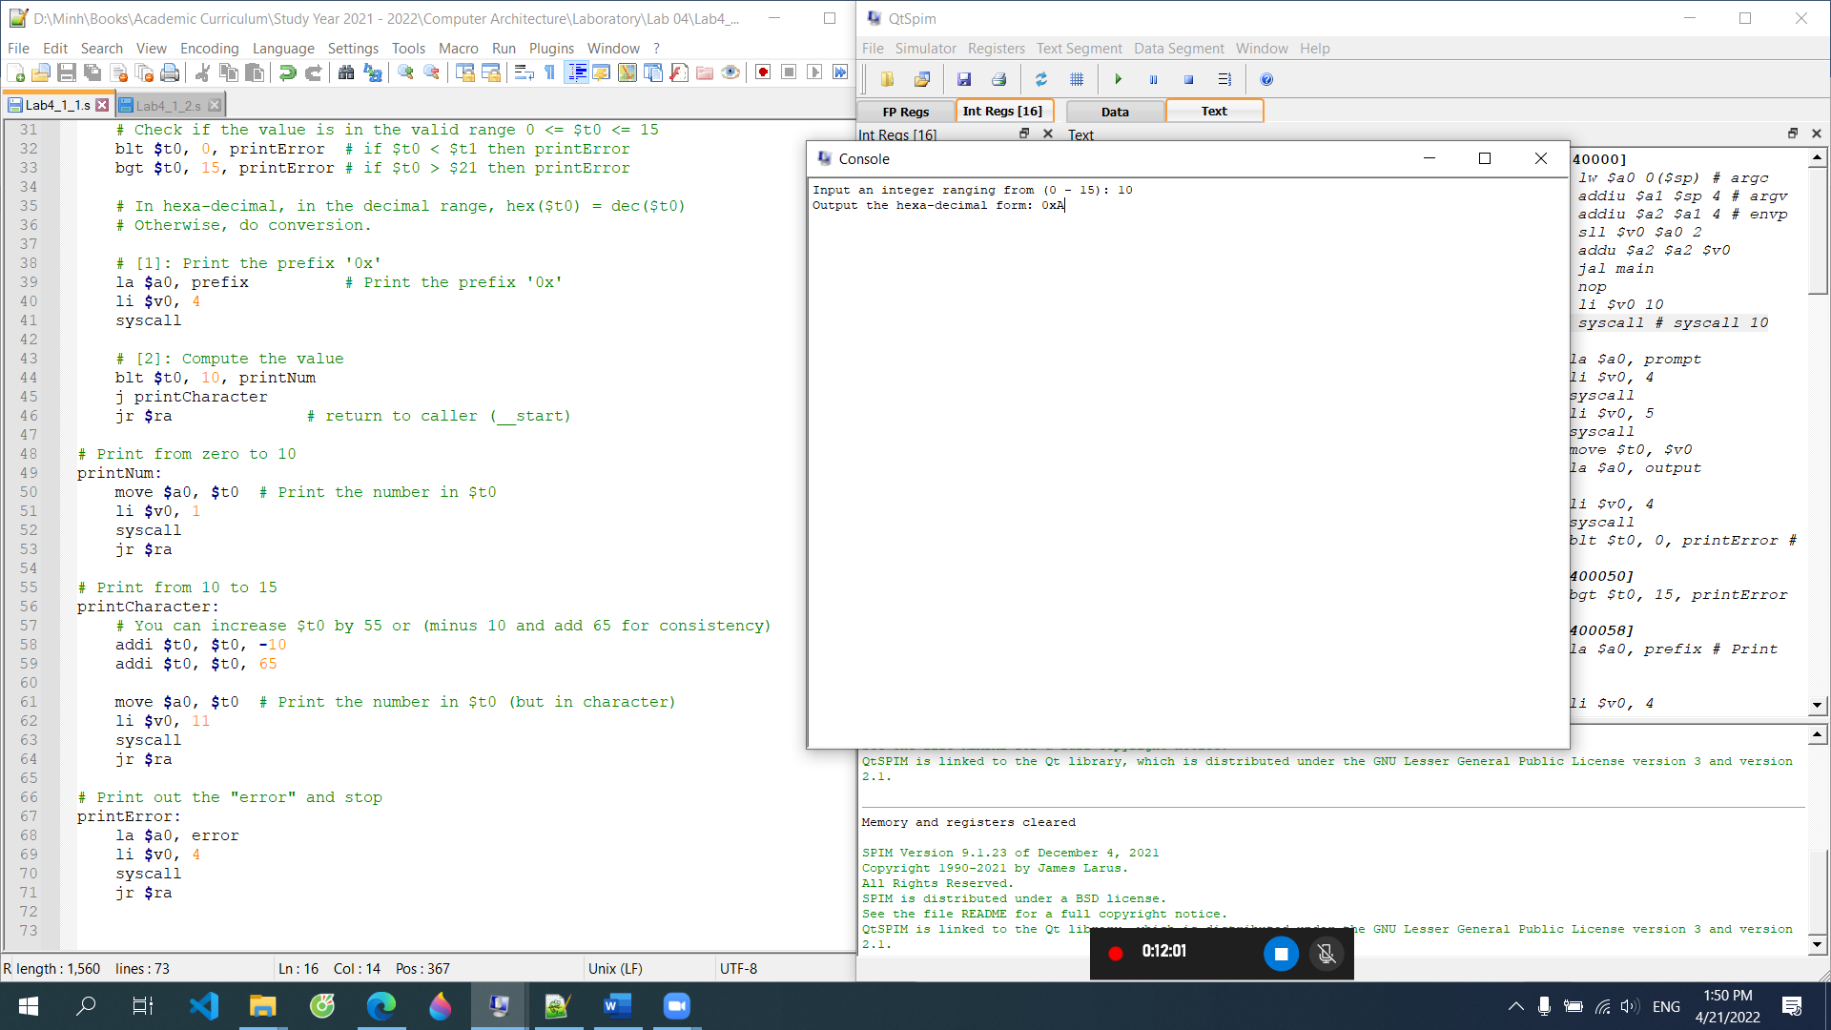
Algo
Check input (0,15) value

Input (0,9) print directly number 0x0 and prefix (0x)
Input (10,15) print 0x and character (A,B,C,D,E,F) increasing 55 (output=input+55)
- Print (output under call service character, v0=11)
- 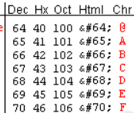
Else: invalid input
Main code:

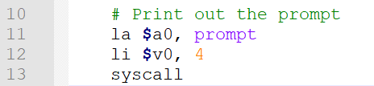 | print: "Input an integer ranging from (0 - 15): "
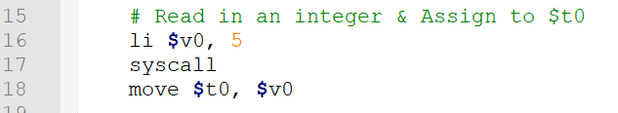 | -read input from console (line 16,17), default stored it in reg v0  -move the input to reg t0, release v0
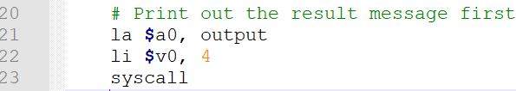 | -print "Output the hexa-decimal form: "
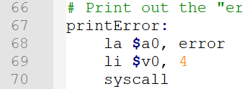 | Compare t0<0 (blt), true goto printError  (line 67-70) "Unvalid input (0-15)\n"  Not True: continue to the next instruction (line 33)
Compare: t0<15 goto error (67-70)
Not true: 0<t0<=15, continue to line 39
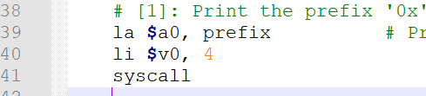 | Print prefix:  "0x" and continue to line 44
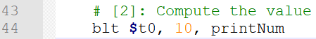 | Compare t0<10, True: print number directly, goto printNum (line 49-53)  Not: jump character (line 45)  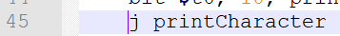
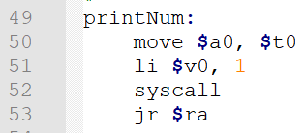
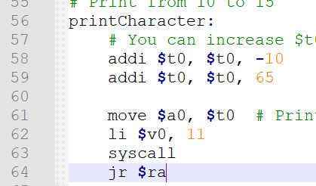

Data segment
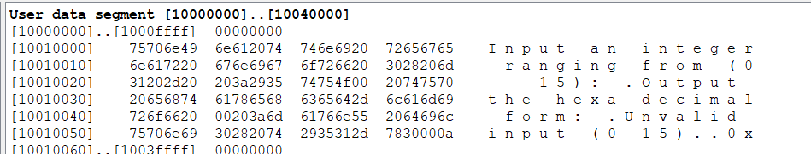
The address of output message: 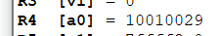 how to get the value?

Case 1: Input=9 check line 32 is not true and goto line 33
Could you explain slti $1, $8, 16?
Could you explain the address of the 1st calling printError 0x00400050]
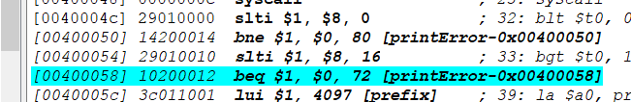
and the second calling printError 0x00400058
print prefix: 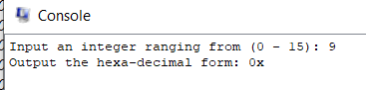
Before goto printNum, the address of printNum: 0x00400070
Bne $1, $0, 12 offset
12 is decimal hex is c
12 [printNum-0x00400070]
12 - c
=0x0040007c

Goto the address: 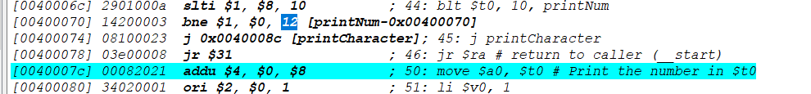
And print out
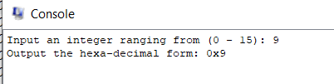

Case 2: input: 13
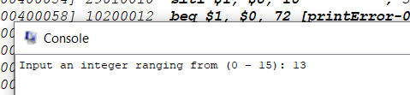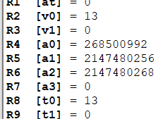
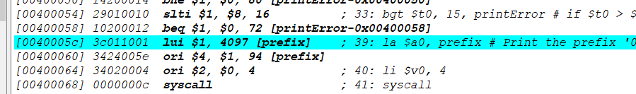
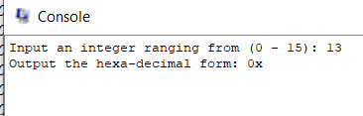
Input: 13> 10 goto printCharacter shown in Figure below
This Figure shows the address of printCharacter is 0x004008c
If you click the next step, you have the next Fig (that is high….)
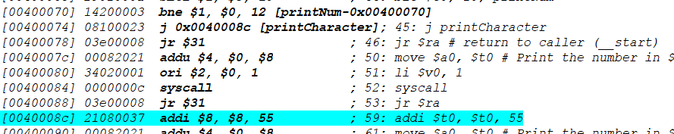
Increase 55
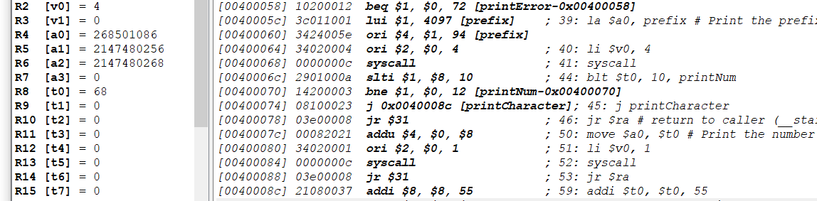
Input 13+55=68 it is character D
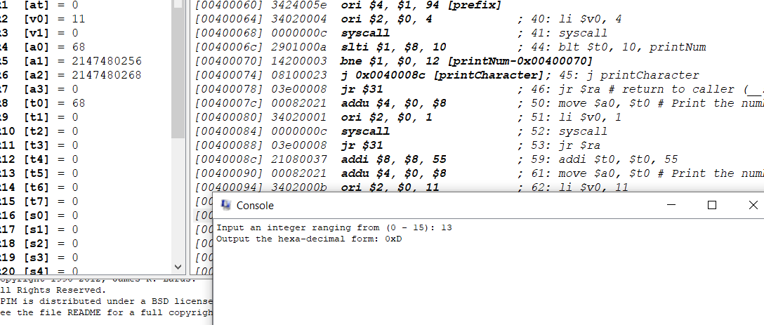

Case 3: input 16
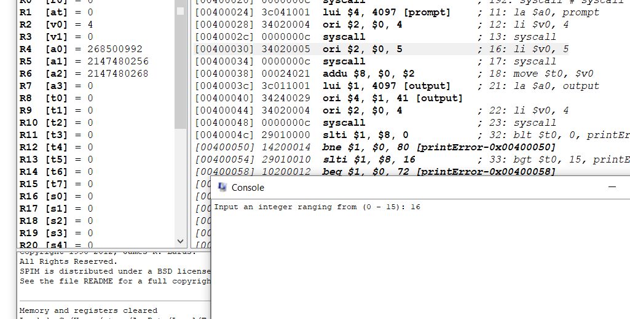

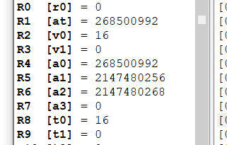
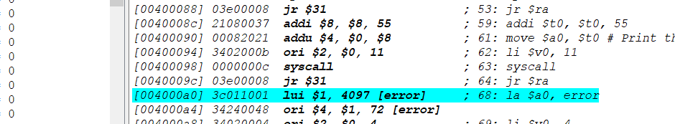
What to learn: 1.1:
When call label goto address (case 1, case 2)

1.2) Modify the previous assembly, create a procedure printHex(int num). This procedure takes in a number and print it out in hexadecimal. (lab4_1_2.s)
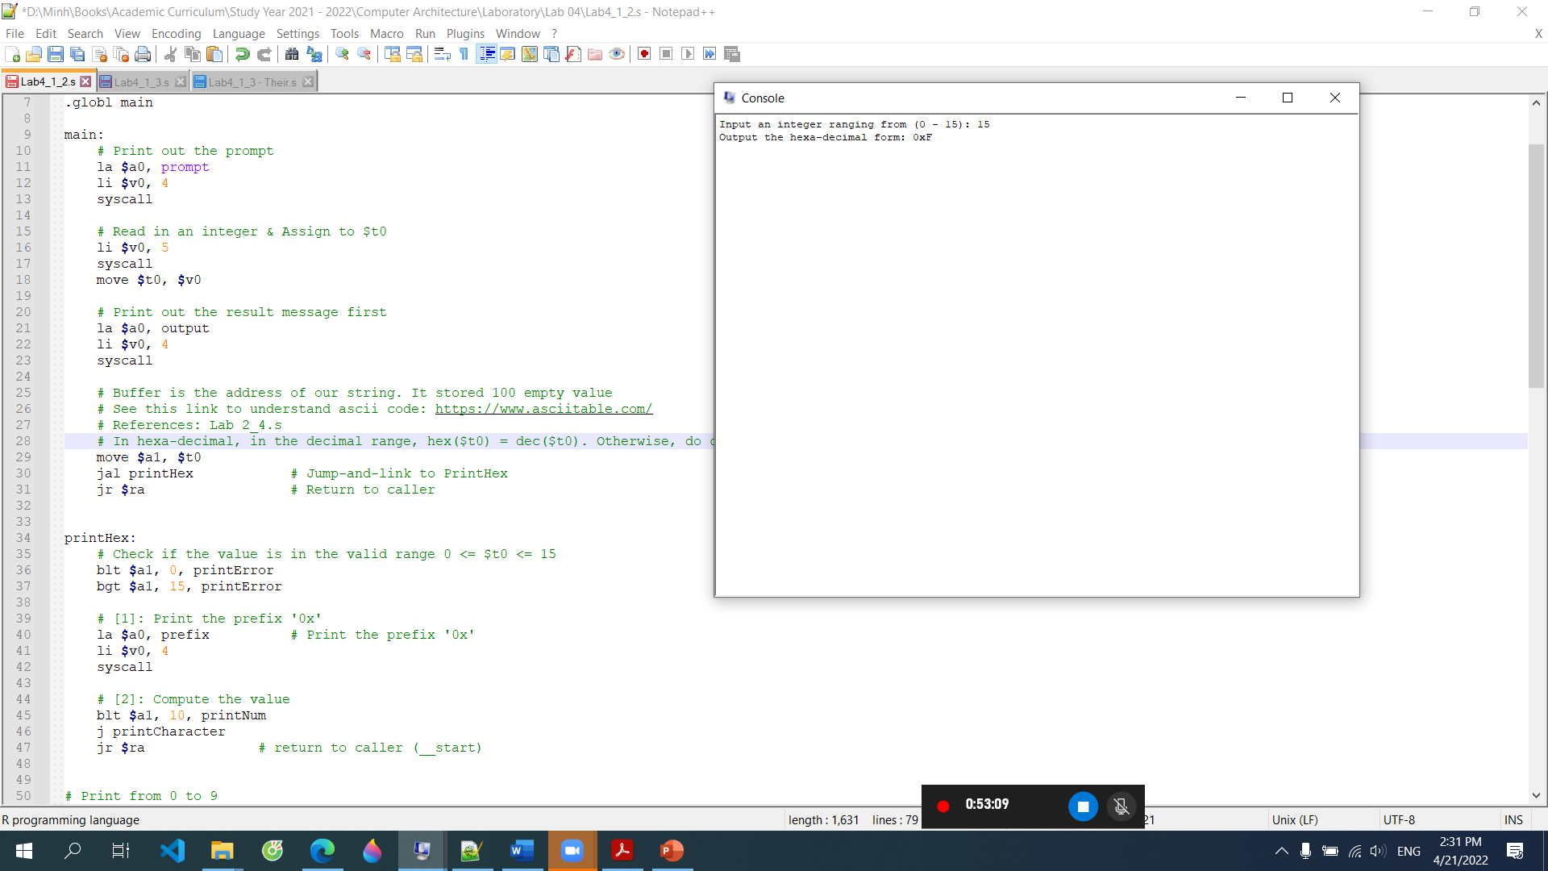
Line 30: call procedure printHex(int num)
Line (34-47):
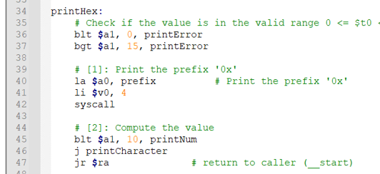

Line 30: call procedure printHex(int num)
Create a procedure printHex(int num)
Question:
1) How to call procedure printHex(int num)
Give me capture
2) what to learn
3) compare 1.1 and 1.2

1.3) Modify the previous assembly so that it can print out hexadecimal of any 32-bit integer input. For example, read in number 546263, print out 0x855D7. (lab4_1_3.s) To ensure result is different, you use the numerical part in your student ID.
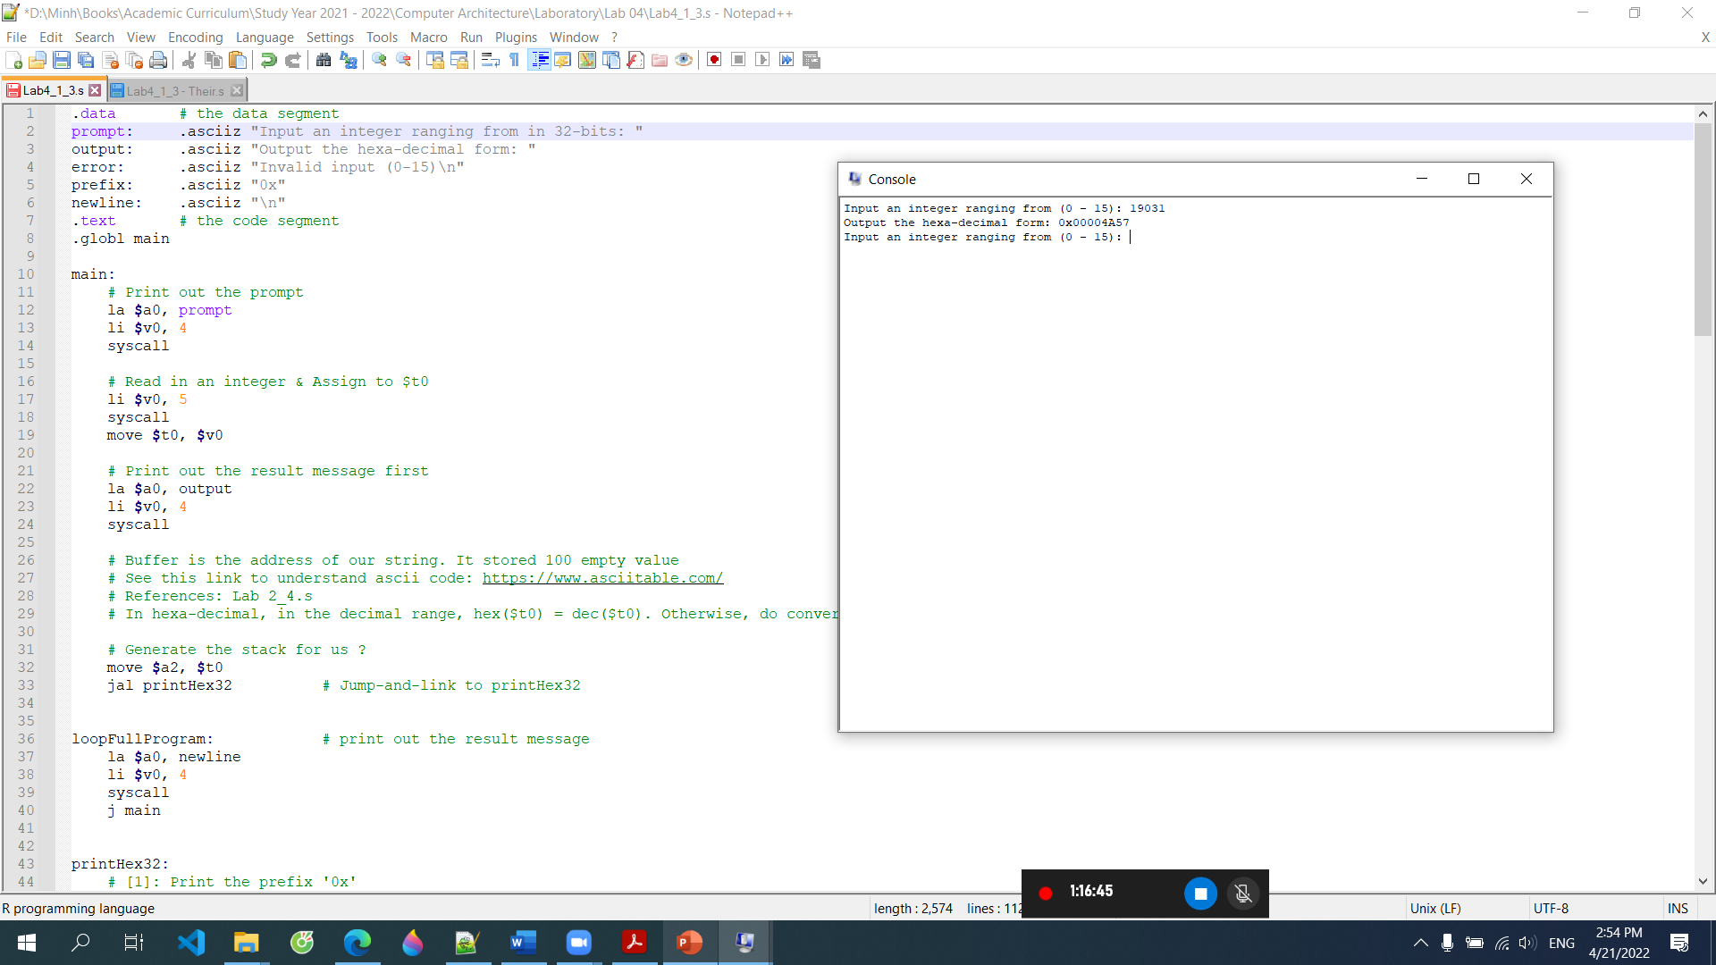
Step 1: give the pseducode
Step2: explain code under step-by-step instructions
Step 3: capture Figure to explain calling a procedure in here
What to learn?
Compare 1.2 and 1.3

Exercise 2: Fibonacci number (50 pts)
The Fibonacci series is defined as: 1, 1, 2, 3, 5, 8, 13, 21, 34, 55, ...
Each term in the series is the sum of the proceeding two terms. So, for example, the term 13 is the sum of the terms 5 and 8.

2.1) Write the program as a counting loop that terminates when the first 100 terms of the series have been computed. Use a register for the current term and a register for the previous term. Each execution of the loop computes a new current term and then copies the old current term to the previous term register. Print out the series. (Use no function) (lab4_2_1.s)
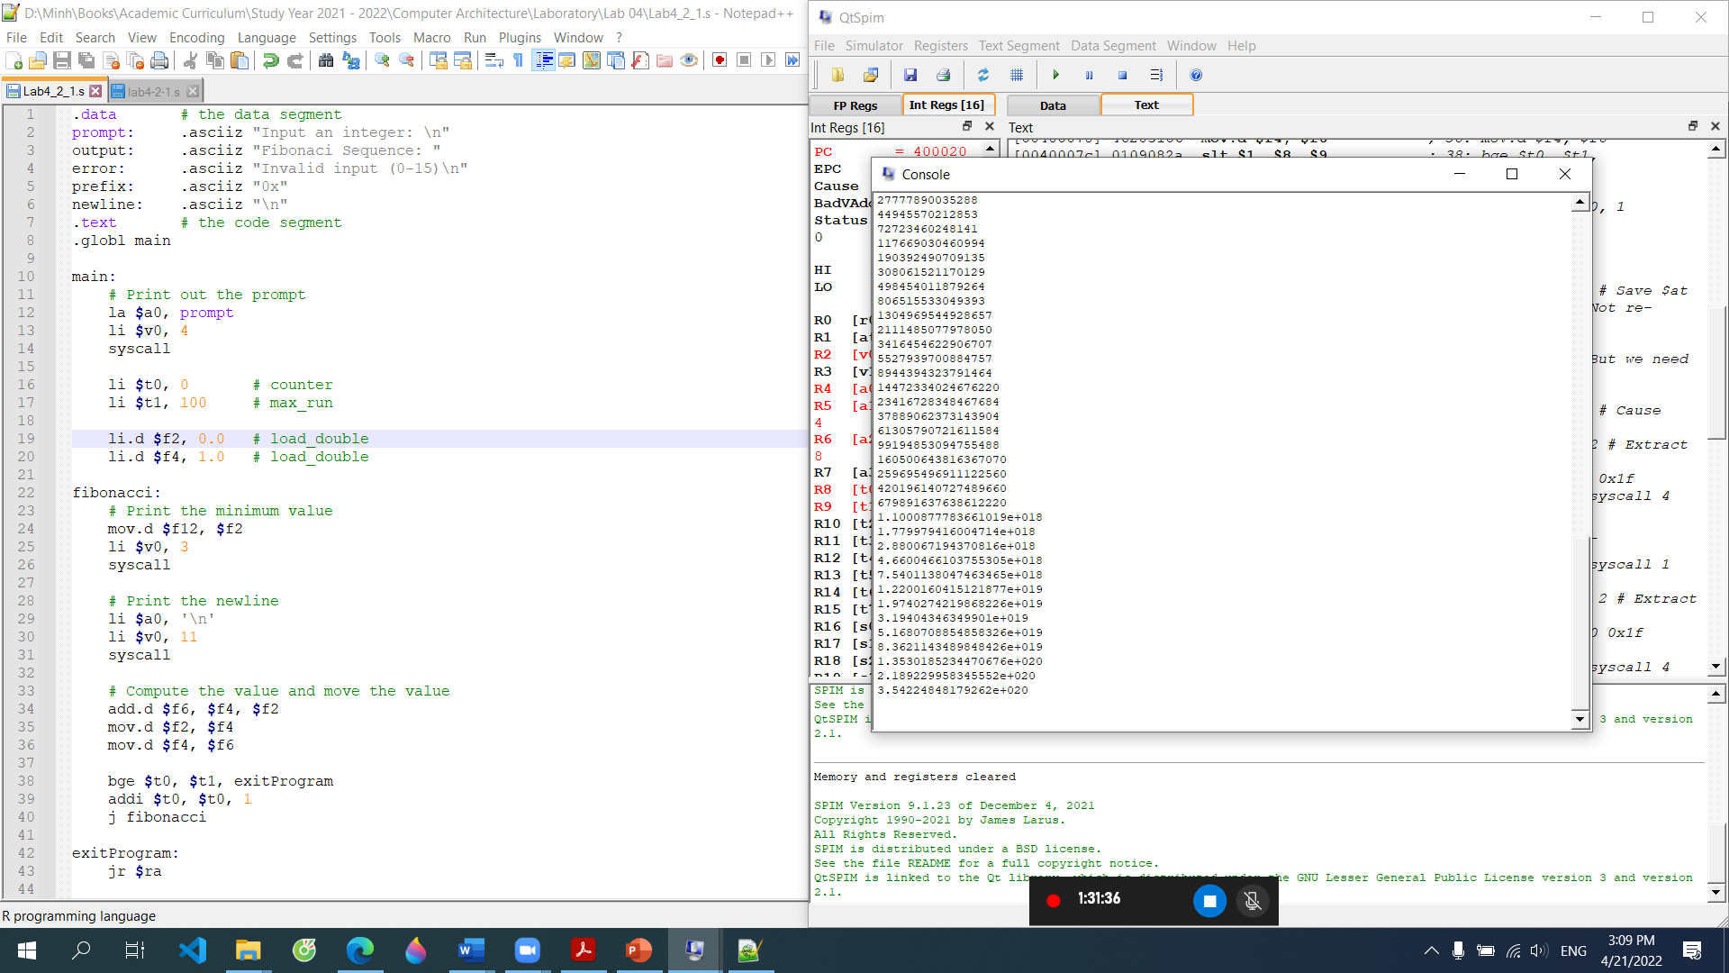
The same part 1, but
- Overflow?
- What to learn?
- Extended exercise?

2.2) Rewrite the program using function
void fibonacci(int numOfTerms); // this is C prototype
This function prints out the Fibonacci series with one input is the number of terms numOfTerms. Use two last number of your ID for numOfTerms.
Explain 2.1 and 2.2, and what to learn

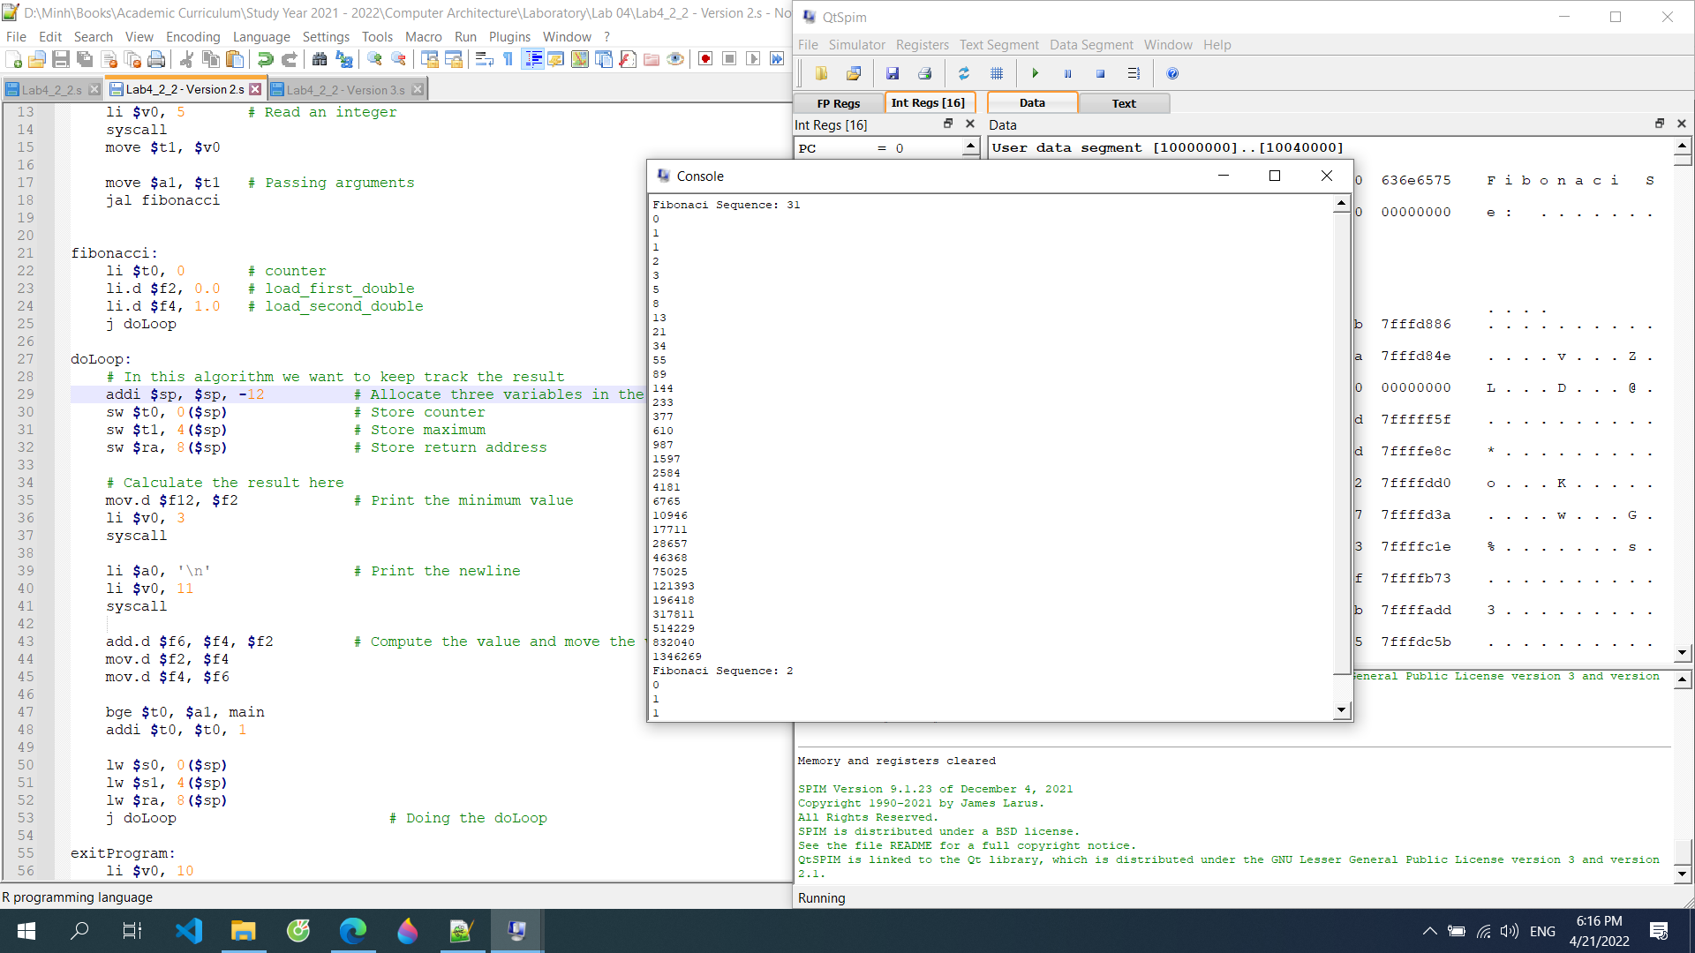

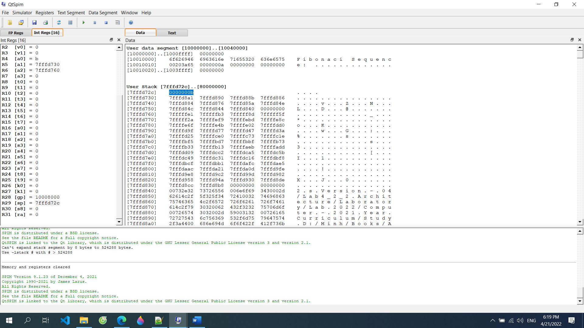

2.3) Rewrite the program using recursion. The fib function should compute the n^{th} term as such:
int fib (int N) {
return fib(N – 1) + fib(N – 2);
}

This is the integer version. However, if you want to scale the result (if your ID is too large), you may want to use lwc1 and swc1 to store the result.
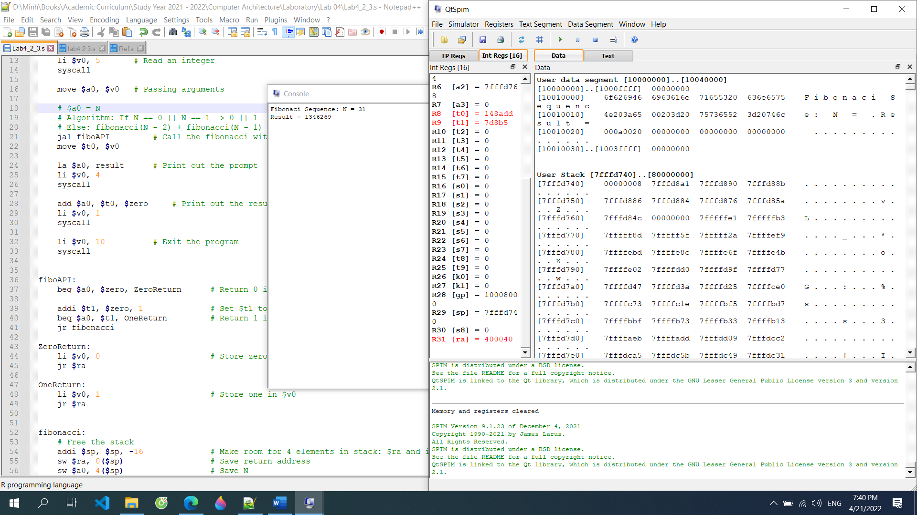

$ra = 400040 which is the place we declare the branch “Fibonacci” (but not the “fiboAPI”)
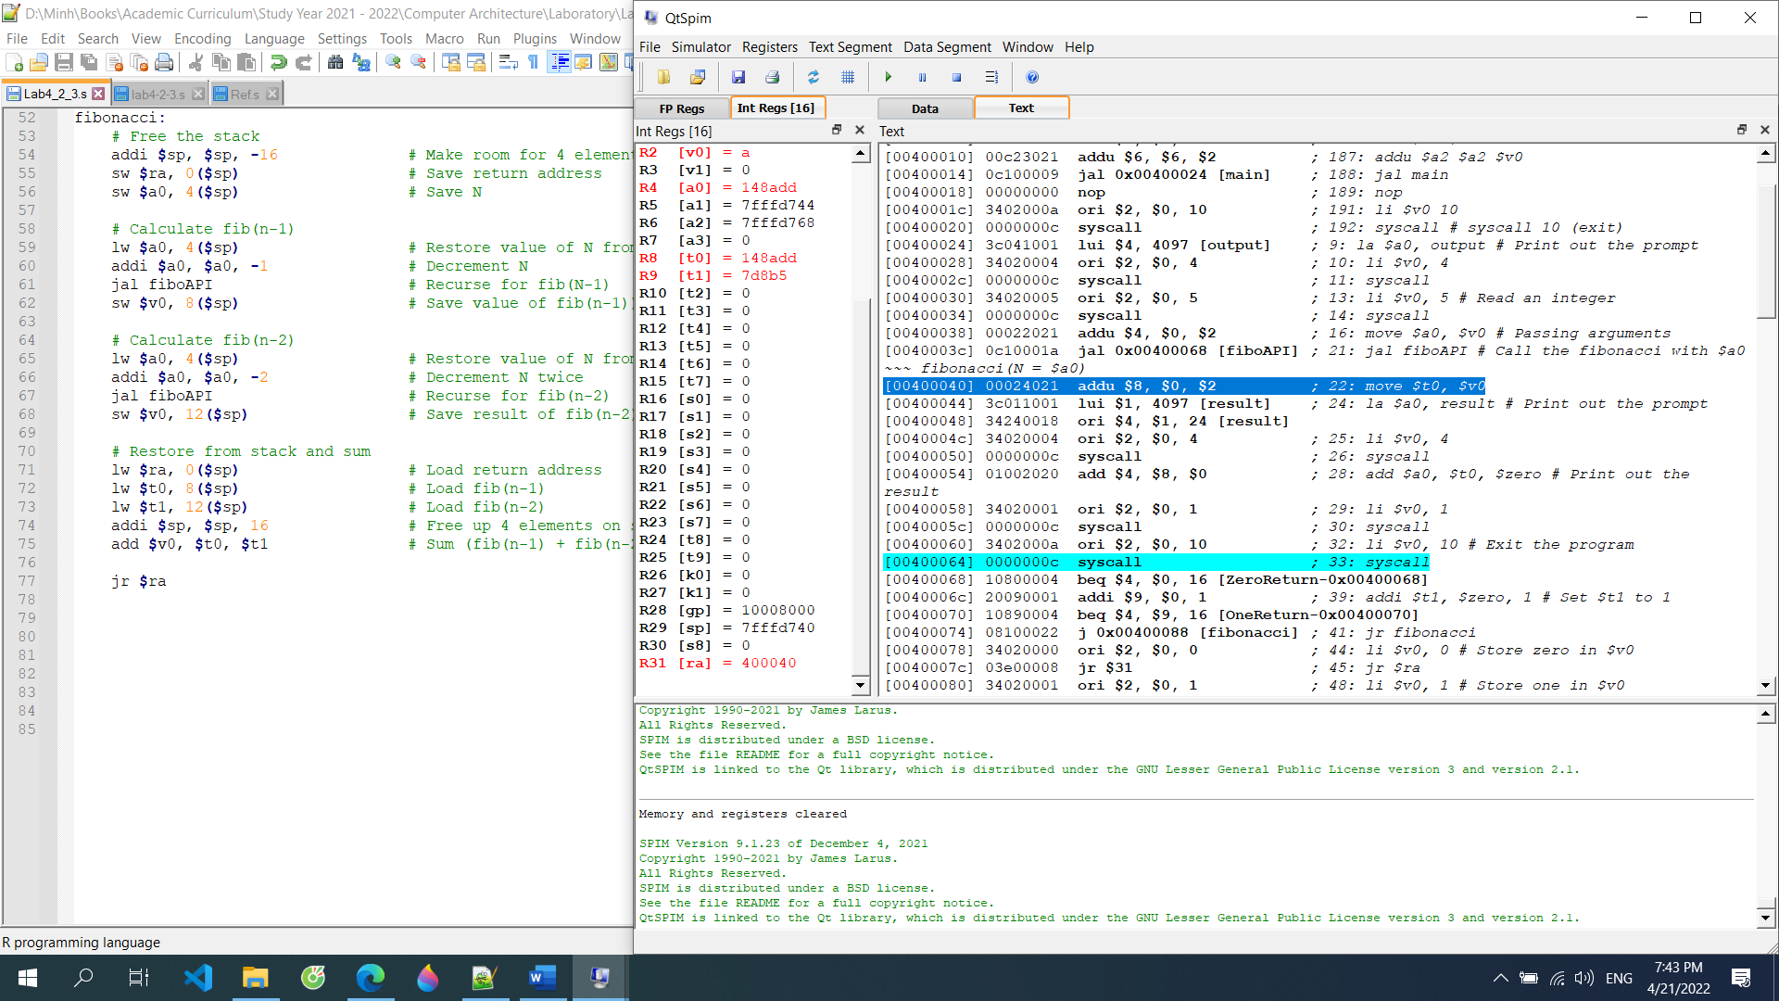

Memory allocation field we have declared. Result (in decimal) on the left
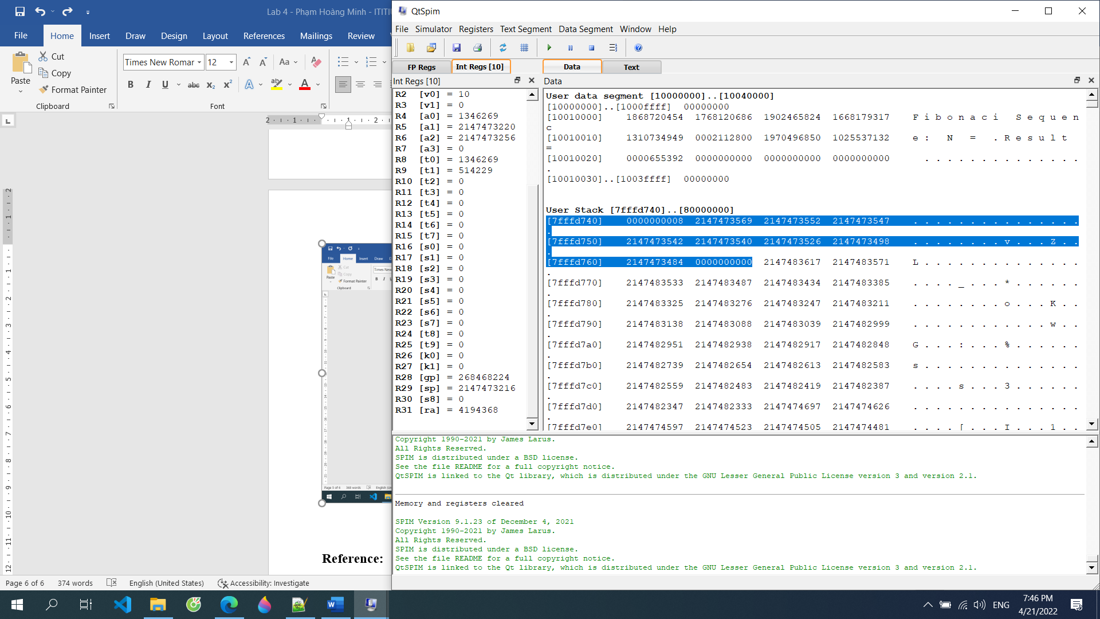

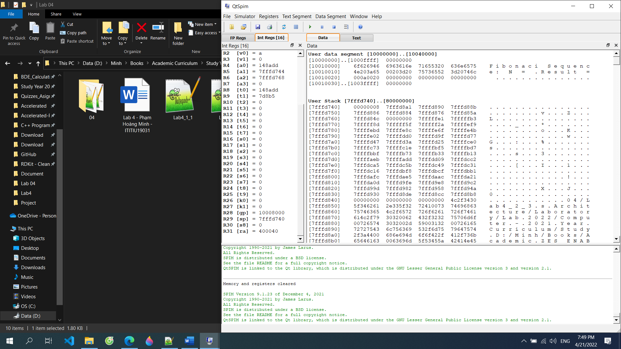

Explain 2.2 and 2.3, and what to learn
In recursion call it in …

Reference:
- https://en.wikibooks.org/wiki/MIPS_Assembly/Pseudoinstructions
- https://courses.missouristate.edu/KenVollmar/MARS/Help/SyscallHelp.html
- https://www.assemblylanguagetuts.com/mips-assembly-programming-tutorials/#MIPS_Data_Types
- https://en.wikibooks.org/wiki/MIPS_Assembly/Arithmetic_Instructions
- https://gab.wallawalla.edu/~curt.nelson/cptr280/lecture/mips%20arithmetic%20instructions.pdf

